Table Creation and Management Exercise

Exercise 1: Create a table named ‘students’ with a column family ‘details’

Exercise 2: Verify that the table has been created.

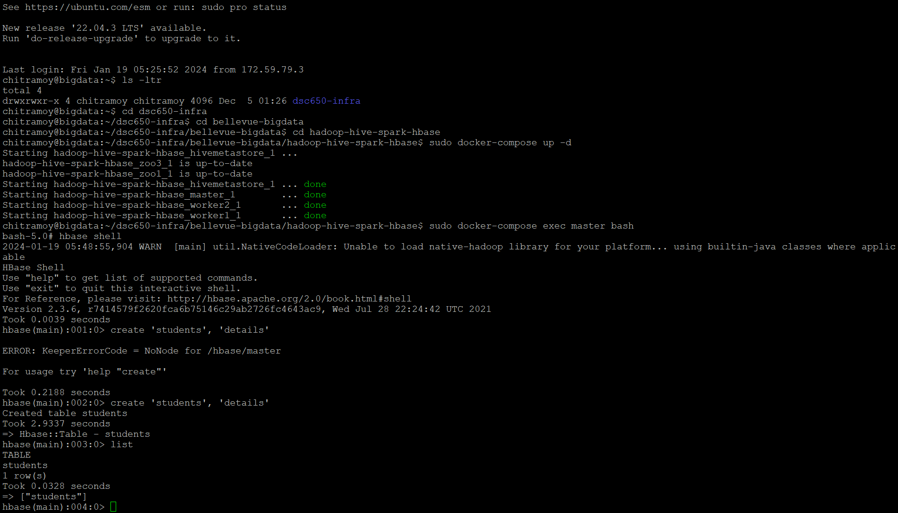

Exercise 3: Add data to the ‘students’ table. Let’s assume each student has a unique ID, a first name, and a last name.

Exercise 4: Query the data from the ‘students’ table to retrieve the details of the student with ID ‘1’.

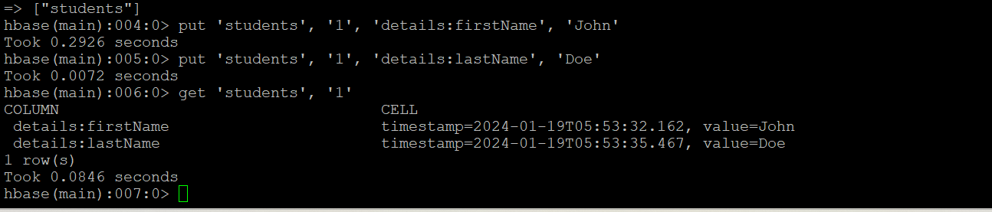

Exercise 5: Create a table named ‘orders’ to store data about customer orders. Assume each order is uniquely identified by a composite key formed by combining the customer ID and order date (in the format YYYYMMDD).

Exercise 6: Add sample data to the ‘orders’ table using the composite key:

Exercise 7: Query the ‘orders’ table to retrieve details of all orders placed by the customer with ID ‘101’.

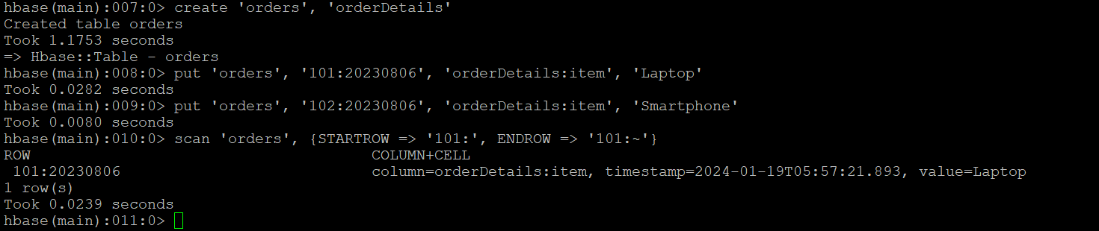

Exercise 8: Generate random data for the ‘students’ table.

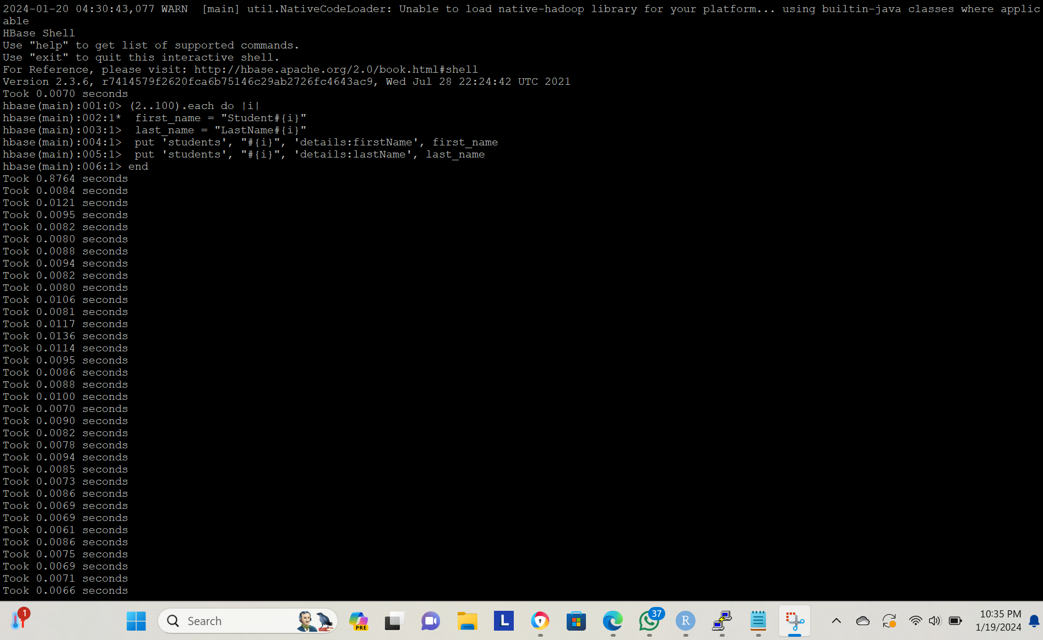



Exercise 9: Scan the ‘students’ table to verify data insertion.

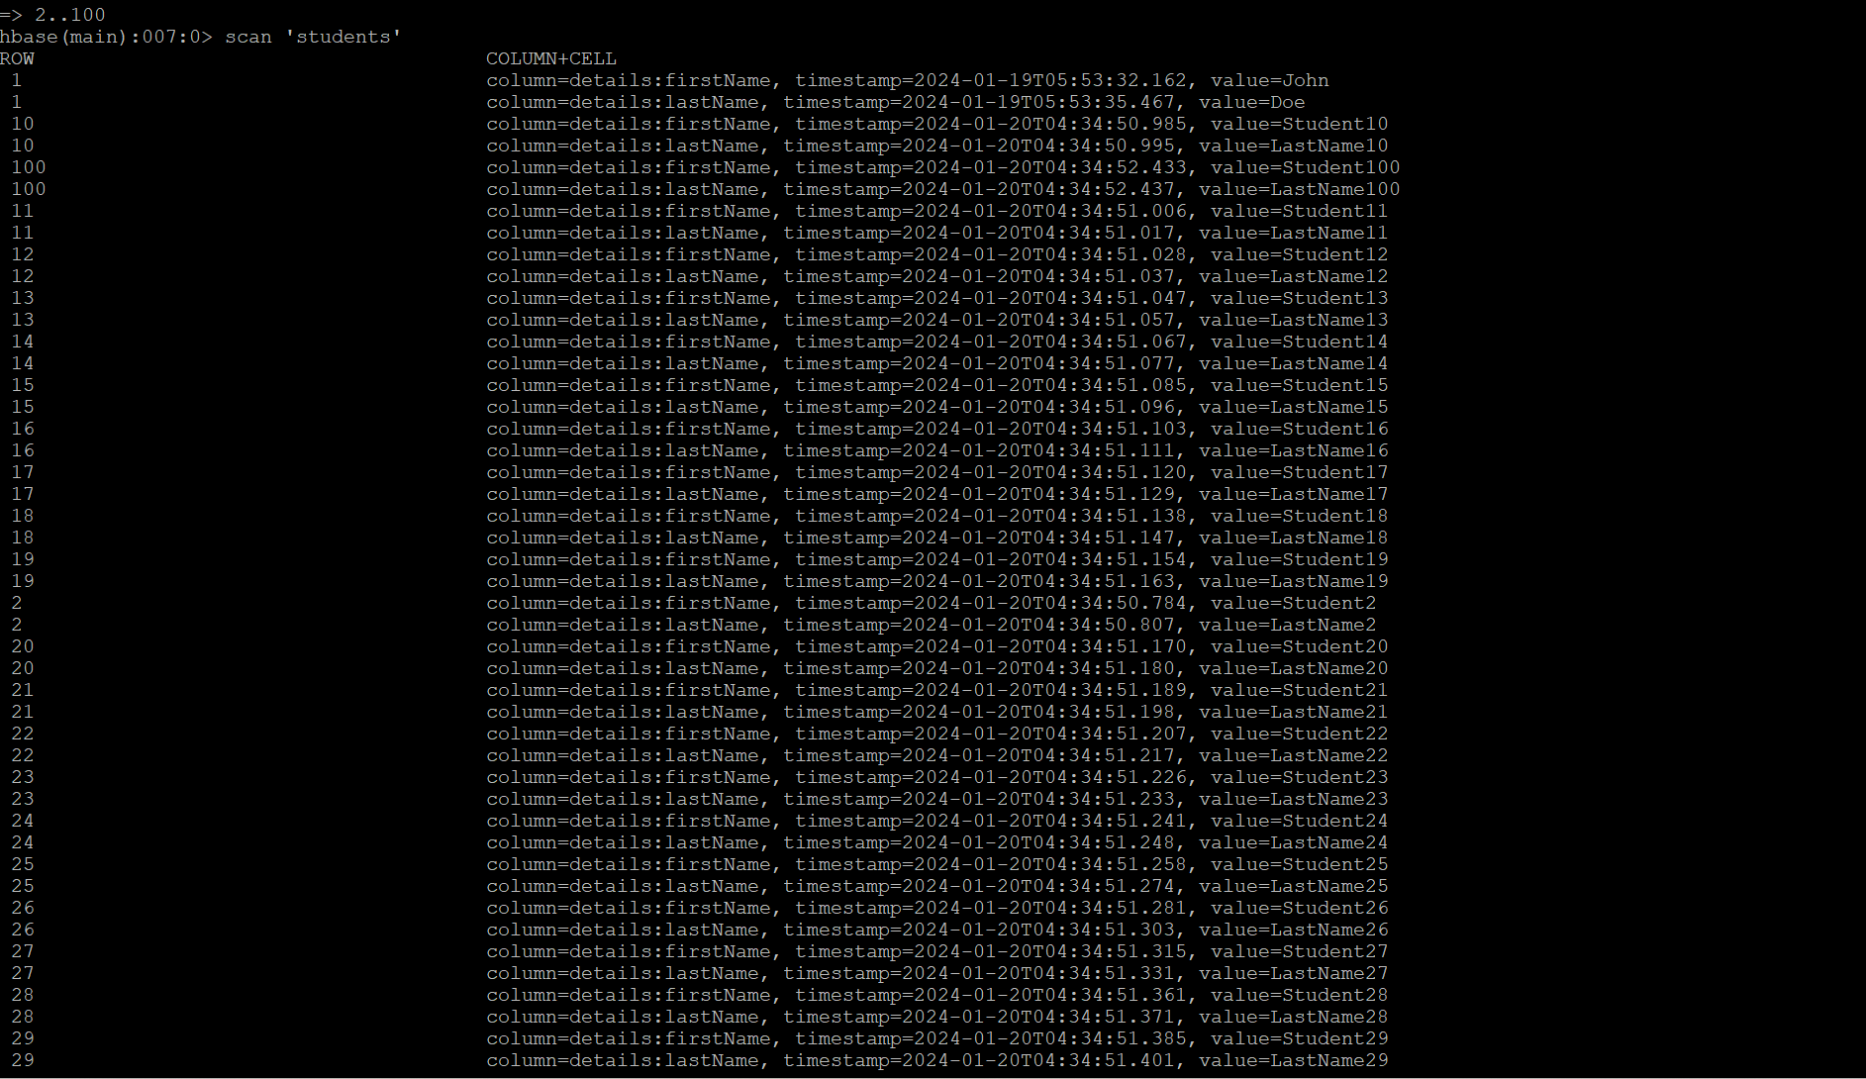

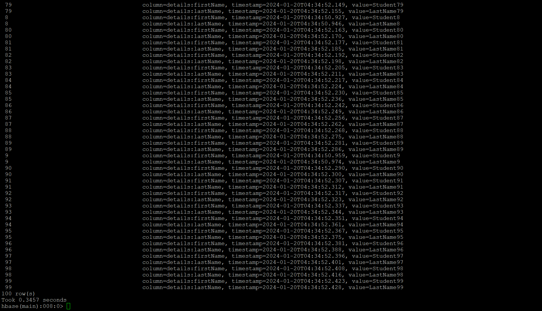

Exercise 10: HBase Data Manipulation

Update First Names: – For students with IDs from 2 to 50, change the first name prefix from Student to Scholar. For instance, Student3 should become Scholar3.

(2..50).each do |i|

first_name = "Scholar#{i}"

put 'students', "#{i}", 'details:firstName', first_name

end

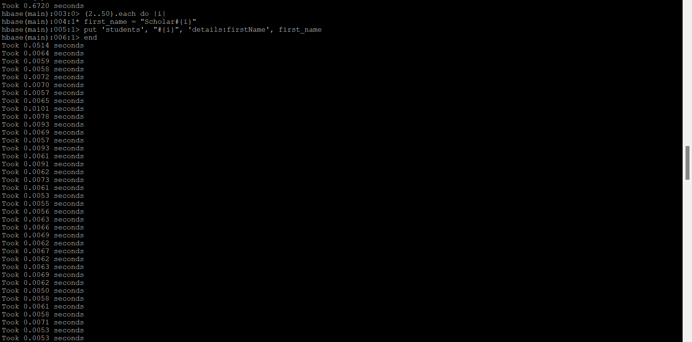

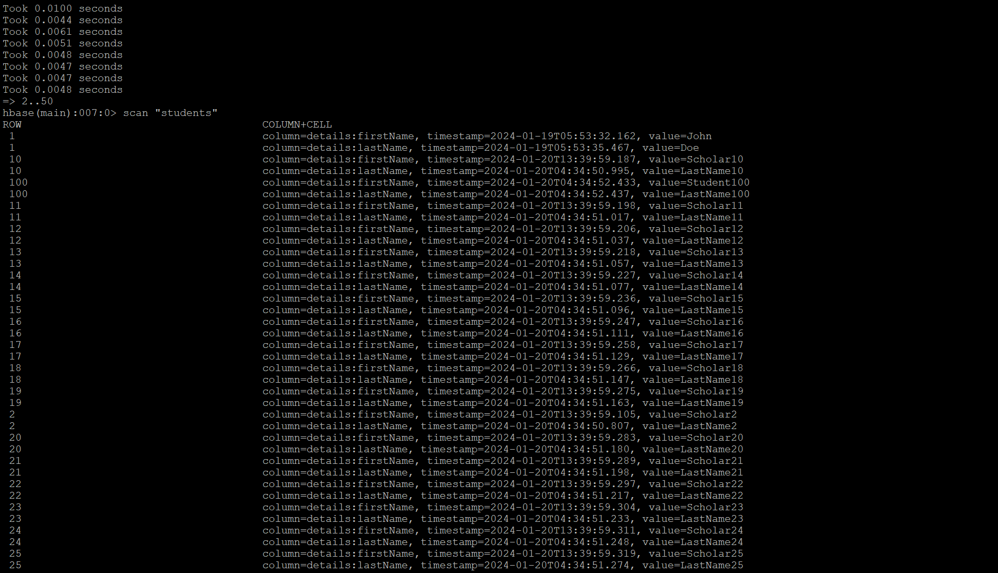

Exercise 10: HBase Data Manipulation

For students with IDs from 51 to 75, add a middle name column under the details column family. The middle name should follow the pattern MidName#{i}.

(51..75).each do |i|

Mid_name = "MidName#{i}"

put 'students', "#{i}", 'details:MidName', Mid_name

end

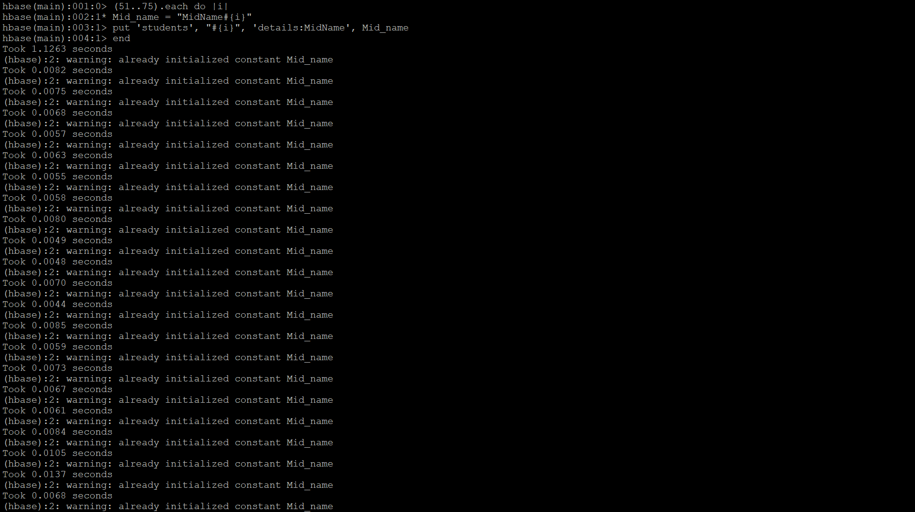

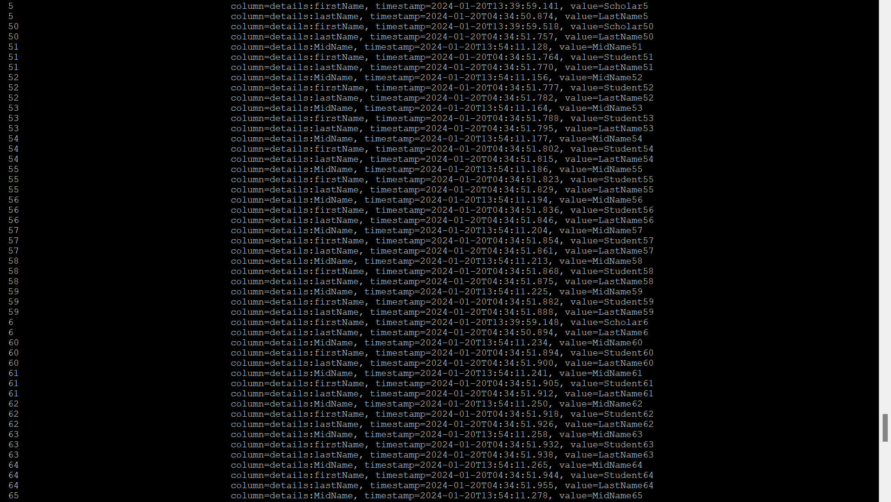

Exercise 10: HBase Data Manipulation

For students with IDs from 76 to 100, append _Modified to the last name. So, LastName76 should be updated to LastName76_Modified.

(76..100).each do |i|

last_name = "LastName#{i}_Modified"

put 'students', "#{i}", 'details:lastName', last_name

end

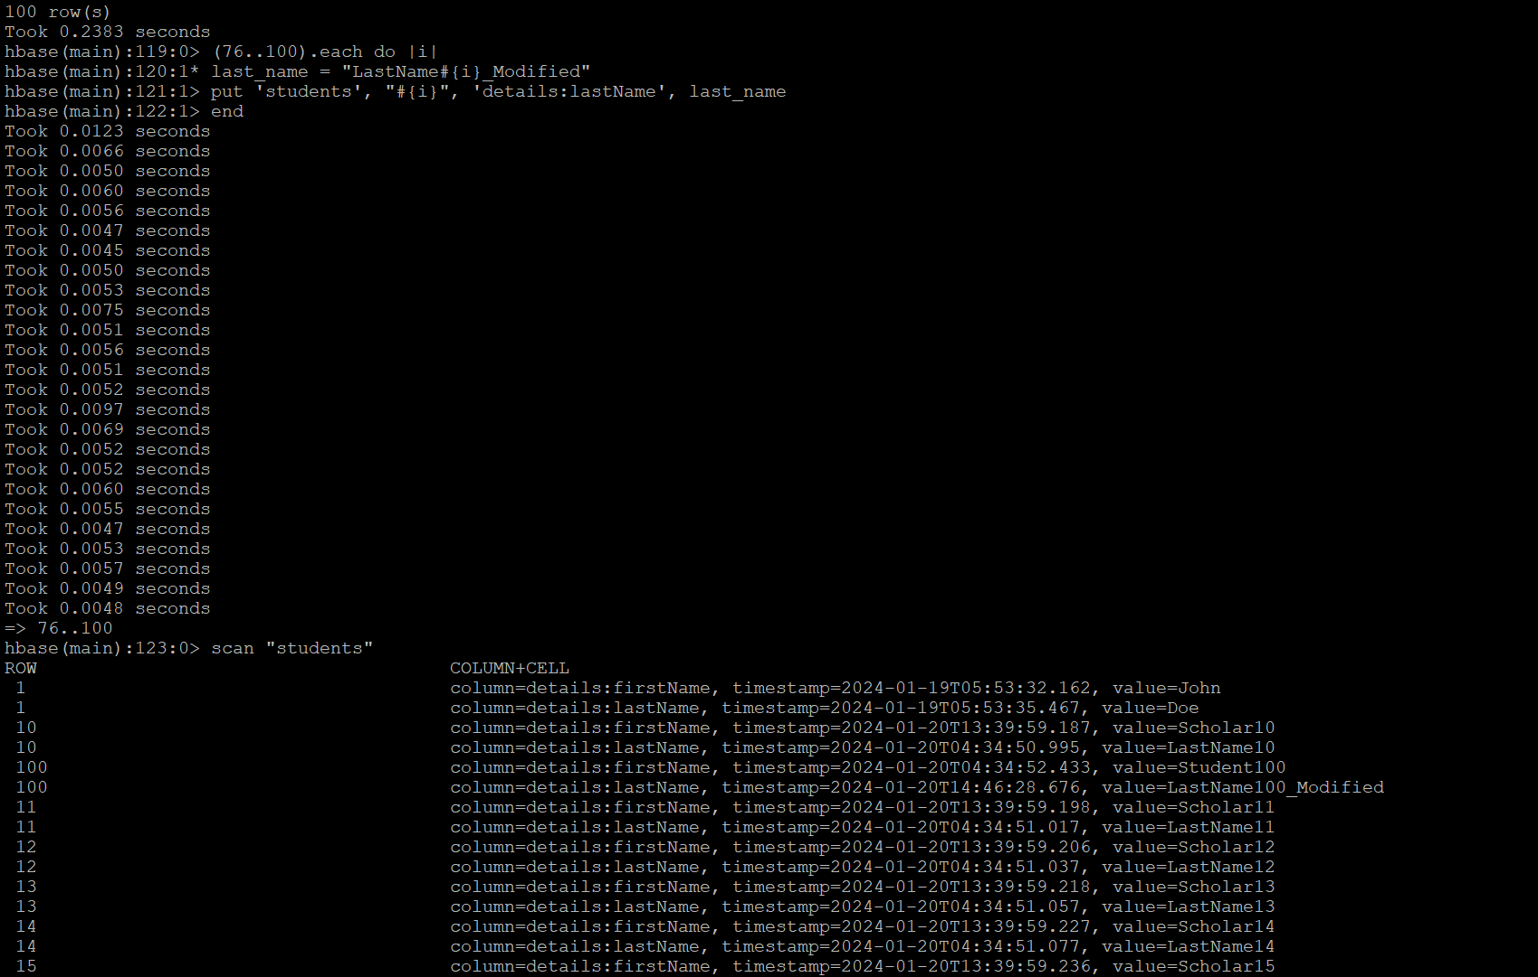

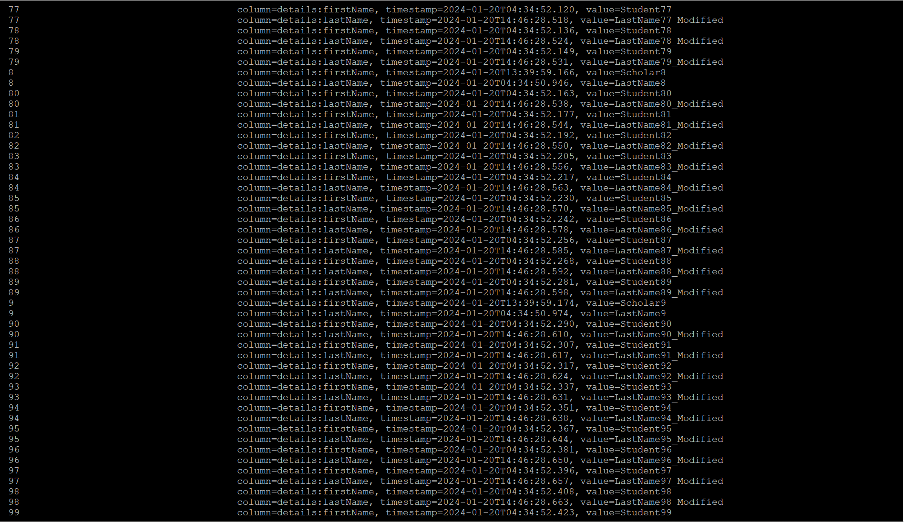

Exercise 10: HBase Data Manipulation

Delete all the details for students with IDs from 90 to 100

(90..100).each do |i|

deleteall 'students', "#{i}"

end

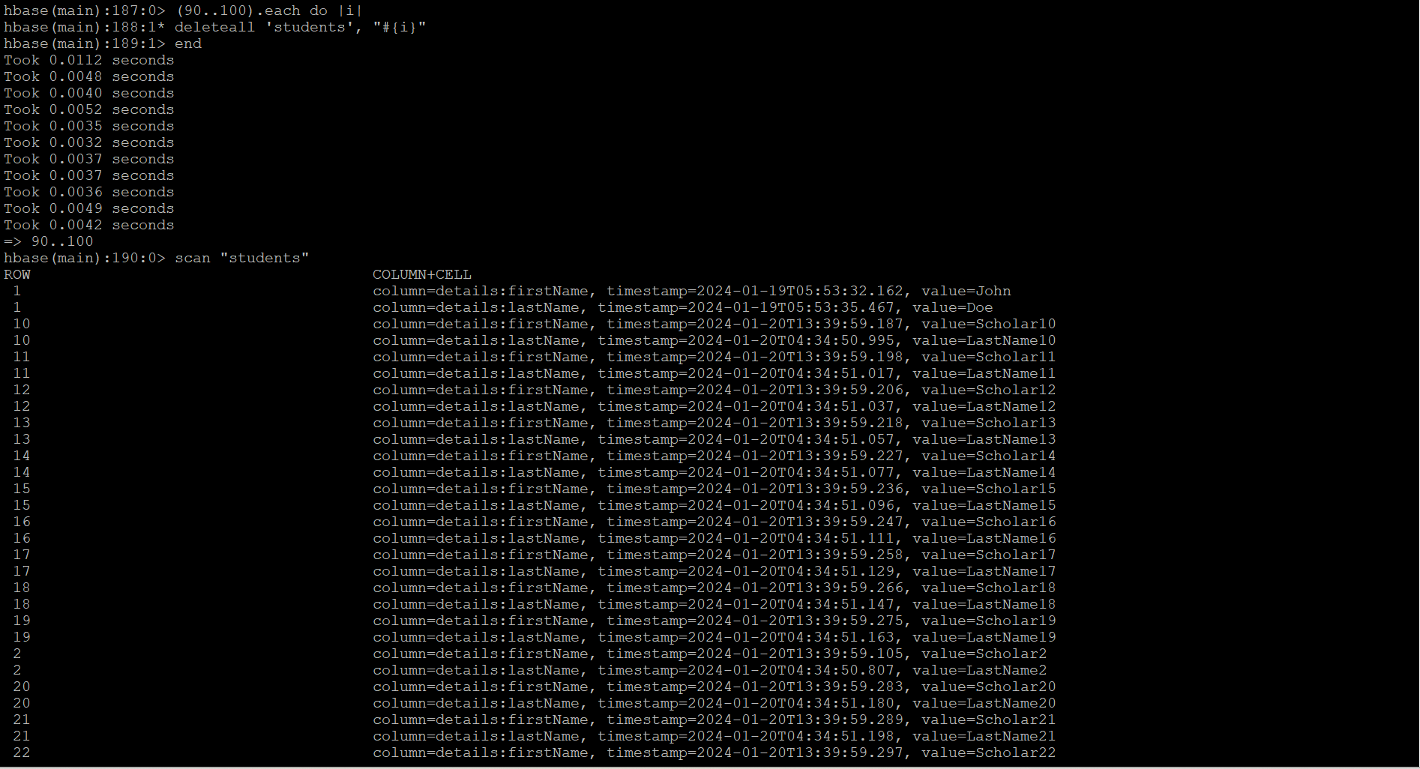

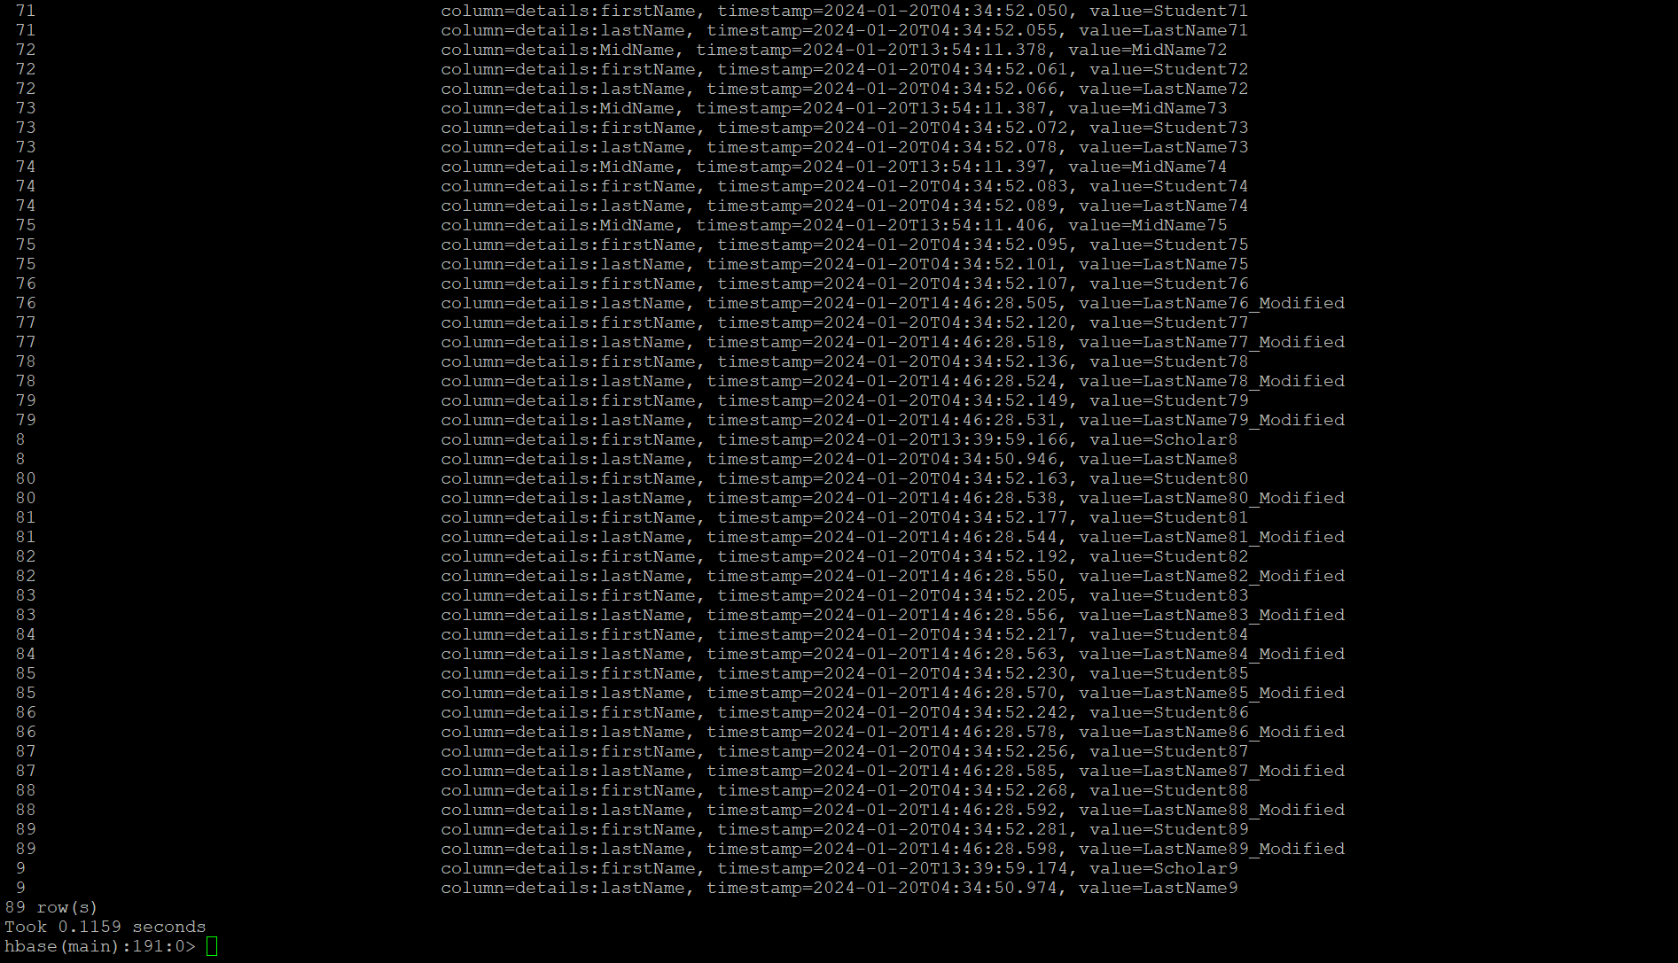

Exercise 10: HBase Data Manipulation

After all modifications, retrieve and display the details for students with IDs 40, 60, 80, and 90 to verify changes.

[40, 60, 80, 90].each do |i|

get 'students', "#{i}"

end

